Packaging Automation Limited

DESIGNERS & MANUFACTURERS

OF PRECISION HEAT SEAL MACHINERY

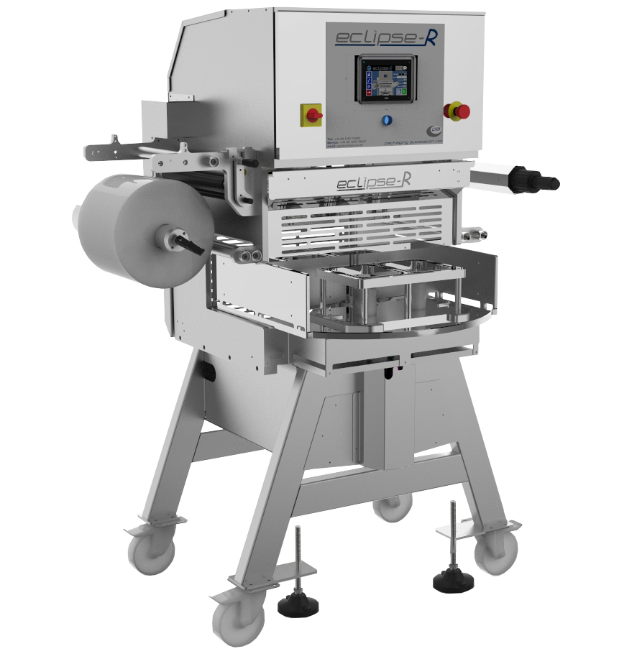

APPRENTICESHIP

APPLICATION FORM

Please complete in block capital letters

PERSONAL DETAILS

Surname: First Name:

Date of Birth:

Address: Telephone:

Email Address: _____________________________

EDUCATION
Schools attended (from 11 years of age onwards).

From To Name & Address of School

SCHOOL EXAMINATIONS
List below the subjects you are studying or have studied and record the results where known.

Subject Level Date Mock Exam Final Exam
Result Result
(If Known) (If Known)

List any other qualifications gained

WORK EXPERIENCE
Please give details of any work experience or part-time work you have had. Start with your most recent.

1) Company Name:
Name of Supervisor:
Address:

Telephone:
From: To:

Nature of Employment:

2) Company Name:
Name of Supervisor:
Address:

Telephone:
From: To:

Nature of Employment:

__________________________________________________________________________
The purpose of the following questions is to help you to think about the skills needed in the apprenticeship role that you have applied for.
The answers that you give to these questions are important and we may ask you to expand upon them at interview. Try and give clear and relevant examples, identify clearly what you did personally and highlight specifically how you contributed.
If you need more space, please continue on a separate sheet of paper, write your name on the top and attach it securely to this form.

1. What is your single, most important reason for applying for an apprenticeship with Packaging Automation?

.

2. Tell us about an event in your life that you feel most proud of.

3. Describe an occasion when you had to undertake a task you disliked. How did you cope and did you finish it successfully? What personal characteristics do you think you had to use to undertake the task and overcome any obstacles?

4. Please give an example of a practical task that you have undertaken; how you planned it and how you overcame any problems or challenges. Examples can be from School, College, Hobbies, Work etc.

5. Thinking back to when you were last part of a group – what did you feel your role was within that group?

(e.g. leader, supportive, decision maker, doer etc.) How did you contribute to the team's success?

6. Please give examples of where you have had to send and receive information to and from others e.g. oral presentations, written reports, School/College group meetings, discussions and debates etc.

7. How would you describe yourself to other people?

8. What are your career/life ambitions and long term goals?

9. Please add any other information that you consider would support of your apprenticeship application e.g. relevant hobbies/interests

HEALTH
Do you need any support in order to be able to attend for interview?

REFERENCES
Please supply two referees, one of which should be School related.

Driving
Do you have a full driving licence? Yes □ No □

I confirm to the best of my knowledge and belief that all information given in this form and any attachments thereto are correct and, if it is subsequently discovered that false or misleading information has been given, this may subsequently lead to the company terminating the apprenticeship. This form should also be signed by your Parent or Guardian.

Signed: Date:

Signed Parent / Guardian: Date:

Please return the completed application form to Dorothy Wainscott, Human Resources Manager,
Packaging Automation Ltd, Parkgate Industrial Park, Knutsford, Cheshire, WA16 8XW.

By signing and returning this application form, you consent to Packaging Automation Ltd, using and keeping information about you provided by you or by third parties, such as referees, relating to your application for future employment.

